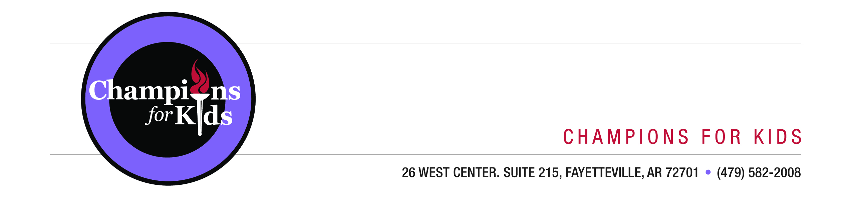

SIMPLE Giving FAQ

1. What is Champions for Kids?

Champions for Kids is a 501(c)(3) non-profit based in Fayetteville, Arkansas. We create SIMPLE ways that make it easy for people to help children in their community. We’ve been operating since 2004, have 22 staff members, and have helped provide resources like nutritious food, school supplies, and personal care items to over 2.02 million children across America.

2. What is a Community Champion?
Community Champions are passionate about improving the lives of children. They keep in contact with the CFK Program Officers as they coordinate various programs to aid the community.

3. What is SIMPLE Giving?

SIMPLE Giving is a Champions for Kids program that provides shoppers with opportunities to donate items to children in their local communities. We will be encouraging shoppers to donate items like nutritious foods, school supplies, and personal care items. We run SIMPLE Giving programs throughout the year, each focused on different needs.

4. What is the August SIMPLE Giving opportunity?

From August 6–20 customers at Walmart stores in 11 states will have the opportunity to make donations in purple donation bins to support children in their local community. These donations will be collected by a Community Champion and distributed to children in the district, so all of the donations will help children in the store’s community.

Additionally, Champions for Kids will provide a total of 12 monetary awards to the school districts that collect the most donations from a single store in a Walmart division. Each of the 4 participating divisions will have a 1st prize of $5,000, a 2nd prize of $1,750, and a 3rd prize of $750. This award could be used for needs associated with the program, but it is not restricted to any one need. Contest rules and a full list of Walmart stores and their corresponding school districts will be available at championsforkids.org/simplegiving.

5. How does a district receive the monetary awards from Champions for Kids?

A full list of contest rules can be found at championsforkids.org/simplegiving, but the basic requirements are:

- Count the donated items you receive from each of your partnered Walmart stores separately. The award will be given to the school district who receives the most donations at a single store, not the total number of donations the district receives. This gives school districts with only one Walmart store an equal opportunity with districts that have multiple stores.
- Take a photo of your donations from each store, and, if you have more than one store, please indicate which store the donations are from. The stores can be distinguished by address or Walmart store number which the customer service desk should be able to provide.
- Email the item total by store and the photos to your Champions for Kids Program Officer by September 2.

6. What does it cost?

It is totally free to participate!

7. Who else is participating?

Our Back-to-School Snacks SIMPLE Giving Program will be running in over 1,400 Walmart stores in 11 states.

8. How many donations should the district expect?

While we cannot guarantee the number of items you will receive, having your community involved greatly increases the rate of success. The results vary widely. Some communities have reaped well over a thousand donations in one drive. It often comes down to the people behind it and the community’s involvement.

9. What can the Community Champion do to raise awareness and generate more donations?

Greater awareness means more opportunities for people to participate! To that end, here are some tips to be successful:

- Post an announcement with the SIMPLE Giving flyer and graphic on the district and school website.
- Share the SIMPLE Giving flyer and graphic on your district’s social media channels—Facebook, Pinterest, Twitter, etc.
  - Visit Champions for Kids on Facebook and Twitter, because we have stories that are easy to “share” with your close friends and community connections
  - For Twitter, use the hashtag #SIMPLEGiving.
- Email or text parents and teachers about the program, attaching the flyer and graphic and sharing the SIMPLE Giving website URL: http://championsforkids.org/simplegiving
- Contact local radio and television stations, newspapers, and news sites to ask if they would be willing to support the program.
- Encourage school administrators to share information about the program in daily announcements.
- Print copies of the flyer and send them home with students in folders, parent newsletters, etc.
- Mention the program at school sporting events, assemblies, and performances.
- Ask local businesses and community organizations to display the SIMPLE Giving flyer or mention the program in their advertisements, social media posts, etc.
- Ask a local sign or billboard company to donate space/time for a SIMPLE Giving sign.

10. Okay, I’d like to participate. What do I need to do?

- Contact your CFK Program Officer and confirm that you will be a Community Champion.
- Visit the store and introduce yourself to the management team. Community Champions have found it helpful to bring a copy of the flyer for reference.
- Rally the community around the program by raising awareness.
- Check in with the store as the program progresses.
- Pick up the donations on Thursday, August 21. Send us separate photos and counts of the donations from each store by September 2. If possible, please take a photo of kids receiving the donations.

11. When will the store know about the program?

Walmart sends a detailed packet of information, called a “playbook,” during the week before the program. The playbook is sent shortly before the materials (displays and bins) arrive to ensure nothing is lost in the rush of running a store. If management is unaware of the program when you speak with them, you’re welcome to explain it. More importantly, please let us know if this occurs so we can work with Walmart to bridge communication gaps in the future.

12. How should I approach my store management?

Ask a representative at the customer service desk for a manager or assistant manager to talk about the SIMPLE Giving program in their store. There may be some initial confusion, so we recommend bringing a copy of the flyer as a point of reference. They should have received a message over the communication system, “WIRE,” on July 28. Once you’ve connected with someone at your store, you’ll be able to ask for them directly on their work days.

13. What kinds of items can the community expect?

Our Back-to-School Snacks Program features breakfast foods and snacks. There will be displays from Dole, Kellogg, and Emerald Foods with recommended donations, but Champions for Kids doesn’t limit donations to these items. While we can’t control what people choose to donate, you can sort and distribute donations appropriately for your students.

14. Who can answer questions about Champions for Kids?

Contact your Champions for Kids Program Officer listed below. You can also call the SIMPLE Giving department at 888-727-1094 or email simplegiving@championsforkids.org

Aaron Weatherford | aaron@championsforkids.org | 479-439-8117
Amanda Reeder | amanda@championsforkids.org | 479-935-1037
Anthony Stevens | anthony@championsforkids.org | 479-316-0624
Brad Zeiler | brad@championsforkids.org | 479-316-0635
Jacob Martin | jacob@championsforkids.org | 479-316-0640
Kristen Martin | kristen@championsforkids.org | 479-439-8119

