Michael Nanney
Superintendent of Education
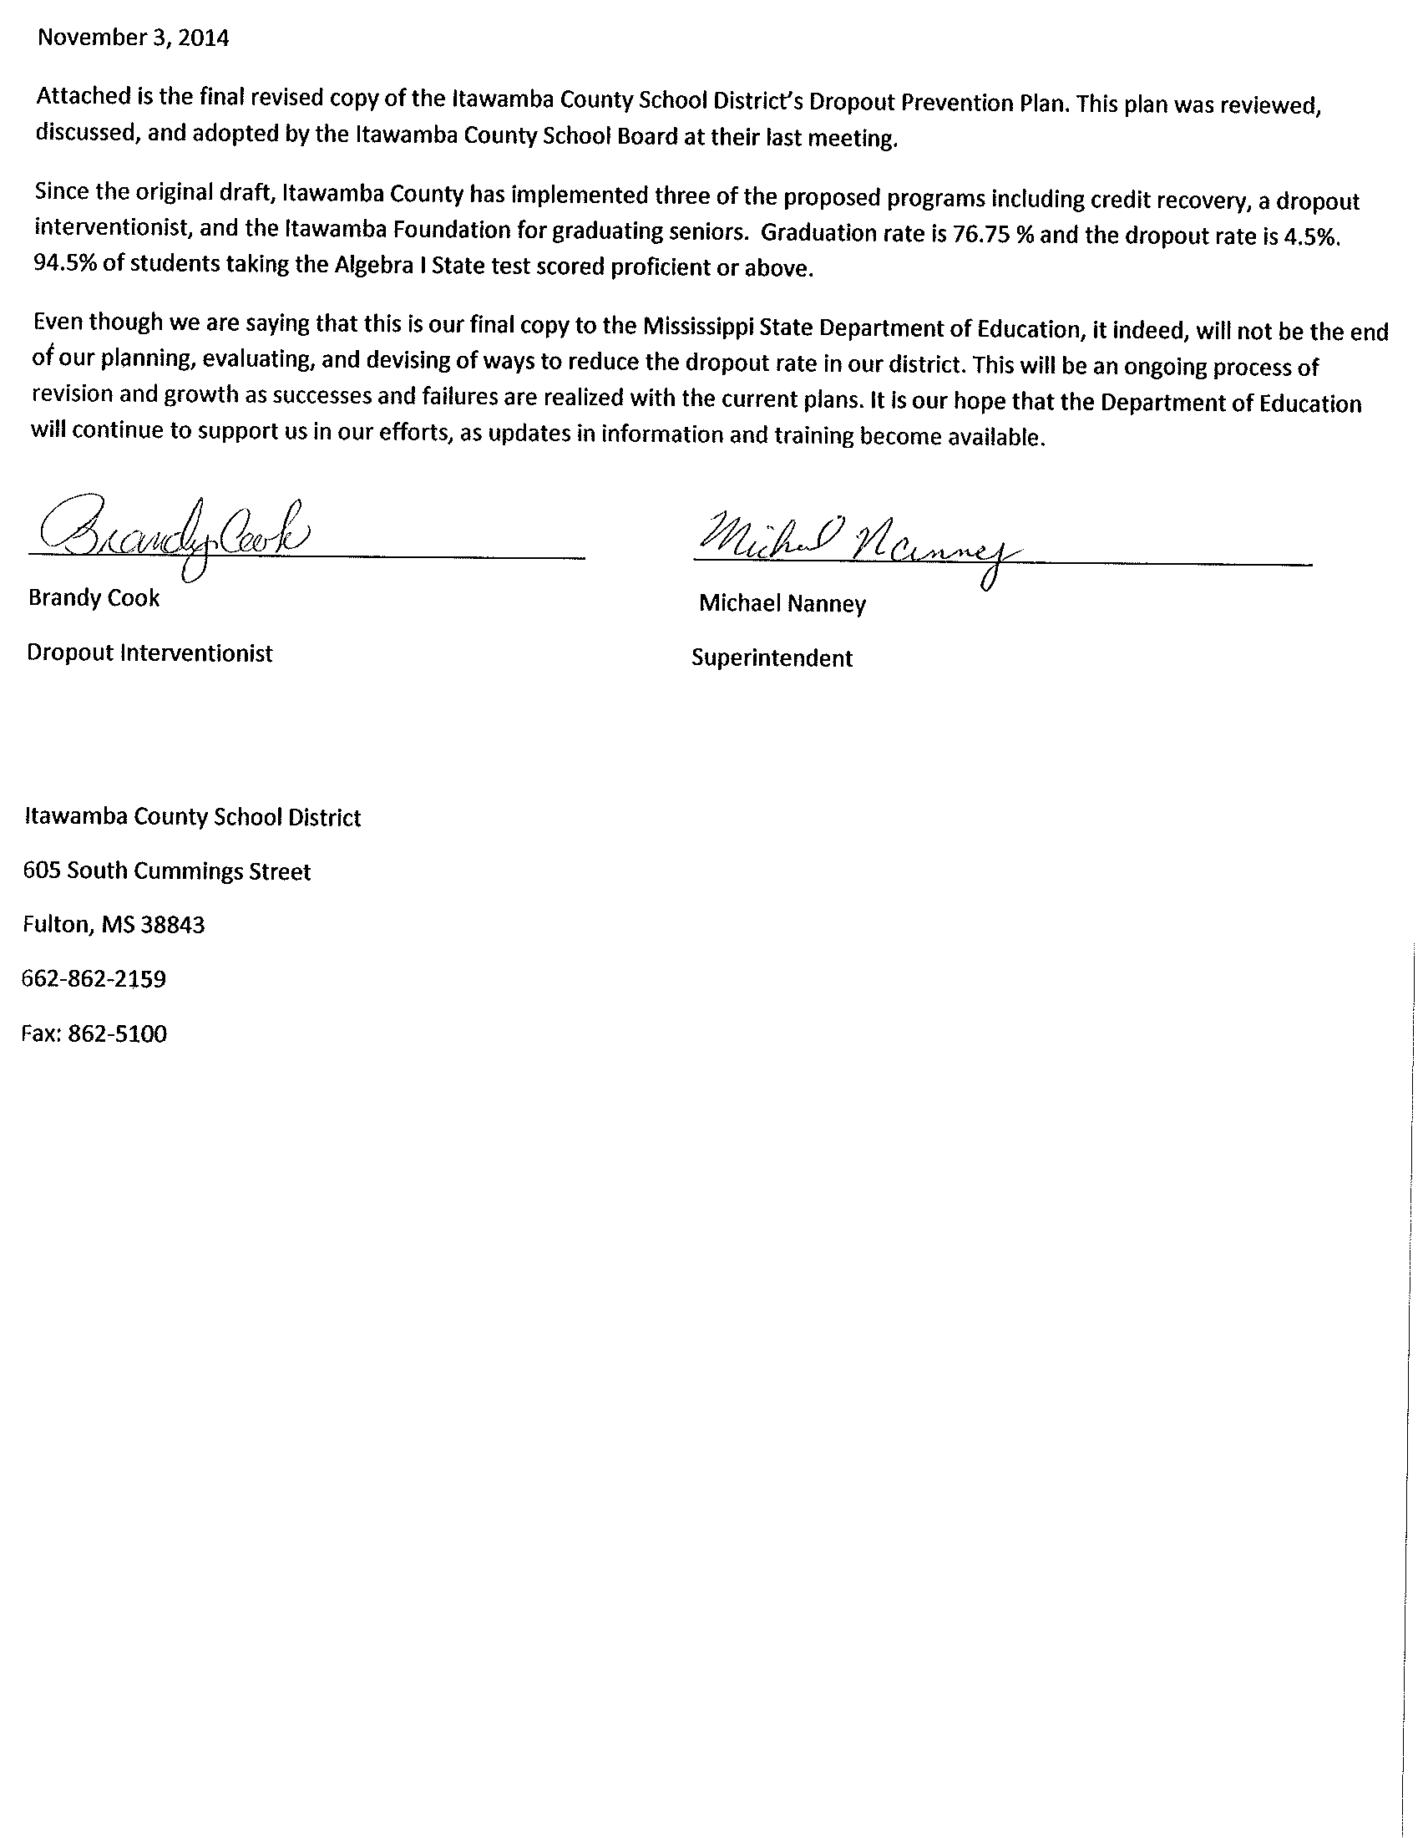
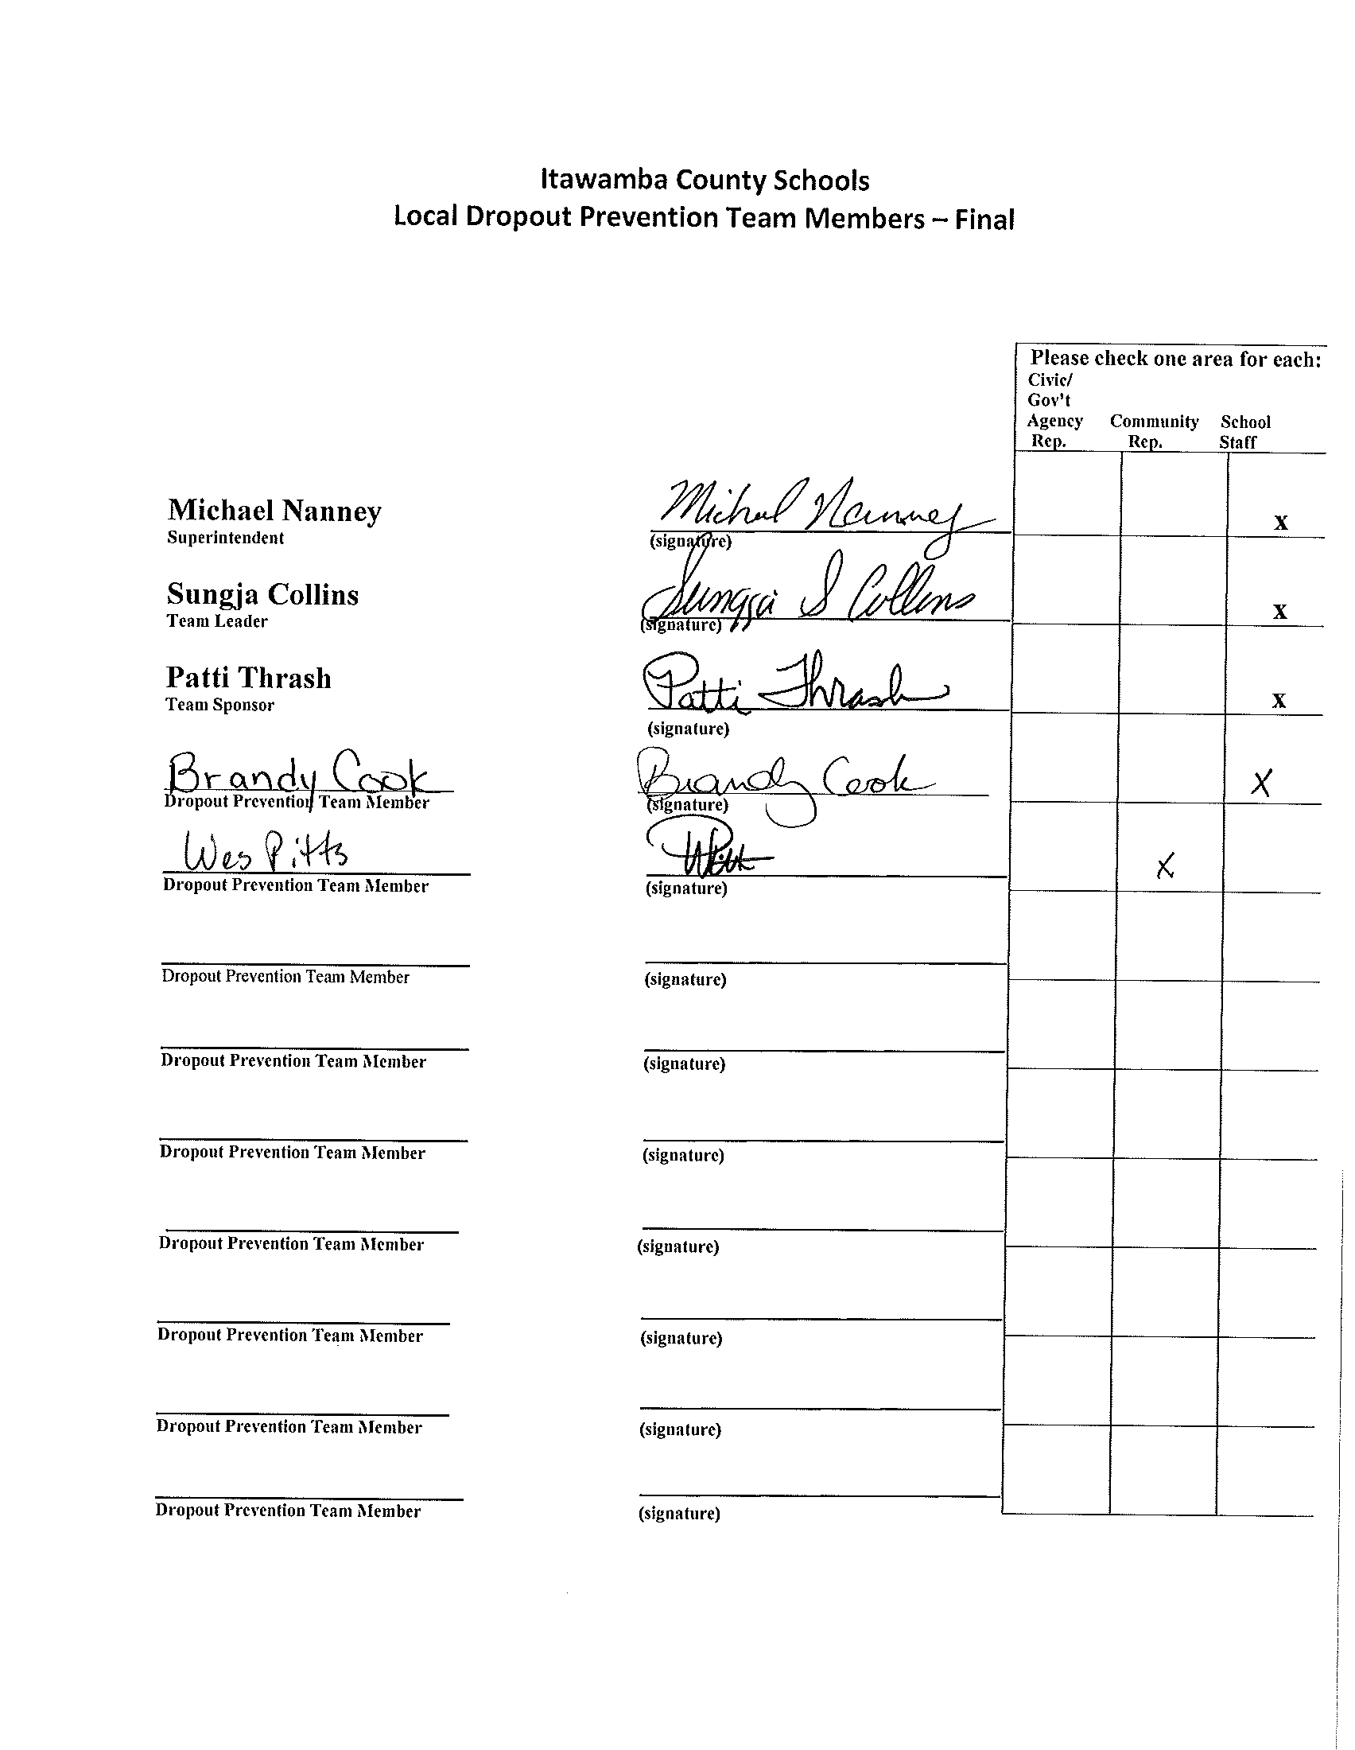

2013-2014 District Data
District Name: Itawamba County Schools
Graduation Rate:76.75% Dropout Rate: 4.5%
 | Elementary School |  | Middle School |  | High School
School Data
Number of Schools | 5 |  |  |  | 3
Cumulative Enrollment | 2525 |  |  |  | 935
Counselor/Student Ratio | 1/505 |  |  |  | 1/312
Student Demographic Data (District Wide)
 | Number |  | Percentage
Female | 1698 |  | 48%
Male | 1831 |  | 52%
Asian | 11 |  | *
Black | 294 |  | *
Hispanic | 30 |  | *
Native American | * |  | *
White | 3174 |  | 90%
Multi-Racial | 15 |  | *
Staff Demographic Data (Teachers/Administrators/Support Staff)
 | Number |  |  | Percentage
Female | 252 |  |  | 79.2%
Male | 66 |  |  | 20.8%
Asian | 0 |  |  | *
Black | 2 |  |  | *
Hispanic | 0 |  |  | *
Native American | 0 |  |  | *
White | 316 |  |  | 99.3%
MCT-Data-Percent Proficient or Above
 | Language Arts |  | Math
Grade 3 | 52.5% |  | 16.6%
Grade 4 | 57.4% |  | 10.6%
Grade 5 | 51.4% |  | 16.3%
Grade 6 | 57.8% |  | 17.7%
Grade 7 | 51.4% |  | 16.5%
Grade 8 | 56.2% |  | 20.5%
High School Subject Area Tests-Percent Proficient or Above
 | Algebra | US History | Biology |  | English II
District Wide | 94.5% | 64.6% | 70.1% |  | 59.4%

Additional District Information
Number of GED Options Program Students  20 | Number of Students Taking the GED Test  20
Number of GED Options Program Students Successfully Completing a GED  17 | Number of Students Passing One or More Sections of the GED Test  20
Average Length of Time Spent in GED Options Program
6 months
Does your District Currently offer a “Fast Track” Program for High School Students?
No
Number of Students Receiving Free/Reduced Meals
2339
Please add any additional or unique data elements in this section

Needs Assessment Outcomes

Needs Assessment Areas | Descriptions
Target Group Identified | Students meeting the profile of “at-risk” of dropping out of high school  Parents of at-risk students  Communities of Itawamba County school children
Data Collection Methods Used | - Grades: Progress Reports for grades K12; Six weeks report cards for grades K-8; Nine Weeks Reports for grades 9-12  - Title 1 surveys of faculty, parents, and students to determine critical concerns and needs in the school system  - Formal Assessments: DIBELS in grades K-3; MCT2 in grades 3-8; State science test results in grades 5 and 8; SAT in grades 9-12; STAR math and reading  - Attendance Reports from MSIS and SAM  - Discipline Reports from MSIS and SAM
Prioritized List of Needs | - Increase Parental Involvement/Communication through workshops, media, newsletters, and one-on-one contact with ICSD Dropout Interventionist  - Reduce Truancy in Itawamba County Schools  - Improve Student Achievement by improving reading scores on the MCT2, and Star, increase the number of students scoring proficient on the MCT2 and SAT  - ICSD’s goal is to decrease the number of discipline referrals by increasing parental involvement, reducing truancy, and improving student achievement
Short Term Goals | - Reduce the number of students with 12 or more unexcused absences by 10% by utilizing a Dropout Prevention Interventionist that will track students in grades 6-12.  - Have a mock-school night for parents at the beginning of school for grades 6-12.  - Increase media coverage of current events at all schools.  - Take steps to improve student achievement by improving reading skills at the elementary and middle schools through use of STAR programs.  - Offer more professional development opportunities in core subject areas so that teachers will be more equipped with the knowledge and skills needed in the classroom.
Long Term Goals | - Continue a Credit Recovery Program for grades 9-12.  - Increase the graduation rate from 76.75% to 78.1% by 2014-2015.  - Decrease the dropout rate to 5% by 2014-2015.  - Reduce truancy rate by 50% by 2014-2015.
Recommendations for future needs assessments | - The district will develop a profile of students who have dropped out of school and evaluate which factors played a role in this decision, i.e. grades, attendance, age, socio-economic background, etc. ICSD Dropout Prevention Interventionist would be responsible for gathering this data.  - The district will also see if a relationship exists between low grades and absenteeism when there are no other deterring variables present by looking at individual student grades as reported in SAM and comparing these to their attendance record. Since students with low grades are serviced through the TST process, the TST team would be responsible for compiling this data and reporting to the district Dropout Prevention Interventionist.  - Manufacturing expectations in a global market. ICSD will ask the major manufacturers in our area for a list of job descriptions, expectations, and requirements for entry-level positions so that we may structure our curriculum around career clusters that will prepare graduates for careers in a global economy.

15 Dropout Prevention Strategies | School / Grade Level
 | District-wide | Pre-Kindergarten | Elementary School | Middle School | High School
Early Childhood Education | - Educational partnering with Head Start  - Reading Eggs  - Accelerated Math  - Accelerated English  - District Website/Parenting Resources  - STAR testing  - Study Island | - Educational partnering with Head Start  - Reading Eggs  - Speech/Language Programs  - Early Prevention Screening | - Reading Eggs  - DIBELS  - Accelerated Math  - Accelerated English  - Early Prevention Screening | - Accelerated Math  - Accelerated English
Early Literacy Development | - District Parent Center  - Educational partnering with Head Start  - Reading Eggs  - Accelerated Math  - Accelerated English  - District Website/Parenting Resources  - TST-Three Tier Process | - Educational partnering with Head Start  - Reading Eggs  - Speech/Language Programs  - District Website/Parenting Resources | - Accelerated Math  - Accelerated English  - District Website/Parenting Resources  - TST-Three Tier Process | - Accelerated Math  - Accelerated English  - District Website/Parenting Resources  - TST-Three Tier Process
Part VI. Current District Initiatives
Program/initiatives are located in Appendix A
15 Dropout Prevention Strategies | School / Grade Level
 | District-wide | Pre-Kindergarten | Elementary School | Middle School |  | High School
Systemic Renewal | - Smart Track Surveys  - Teacher Surveys  - Parent Surveys  - Student Surveys  - School Improvement Plan | - Early Prevention Screening | - Early Prevention Screening  - MCT2 | - MCT2  - Tech Prep Evaluation |  | - SATP  - High School Re-design  - Tech Prep Evaluation  - Project Grad
School-Community Collaboration | - Smart Track Surveys  - Parent Night at local area Head Start Centers |  | - Opportunities to participate in sports and school plays
 |  |  |  | - Craft Committees for Tech Prep  - Career Futures |  | - Career Day  - Craft Committees for Tech Prep
Safe Learning Environments | - Crisis Management Plan  - Alternative School  - Character Education Programs  - No Bullying Policy  - Transition Classroom | - Crisis Drills | - DARE Program  - SRO
Family Engagement | - District Parent Center  - Annual Parent Visitation Night | - Parent Visitation Night  - PTO | - Family Reading Night  - Parent Visitation Night  - Annual Book Fair  - PTO |  | - Parent Visitation Night  - Annual Book Fair  - PTO |  | - Parent Visitation Night  - PTO

15 Dropout Prevention Strategies | School / Grade Level
 | District-wide | Pre-Kindergarten | Elementary School | Middle School |  | High School
Mentoring / Tutoring | - Big Brothers/Big Sisters  - Faith Based Visits |  | - Big Brothers/Big Sisters  - Math Tutoring  - Character Education  - Check and Connect |  |  | - Character Education  - FCA
Service-Learning |  |  |  |  | - DARE Program | - Co-op Programs  - Job Shadowing in Vocational Ed.  - High School Redesign
Alternative Schooling | - Alternative Education  - Transition Program  - TST  - Behavior Interventions  - Counseling as needed |  |  |  |  | - GED Program  - Occupational Track  - Credit Recovery
After-School Opportunities | - Sports  - Annual County Wide Play
Professional Development | - The North Mississippi Education Consortium  - LEA Plan for Highly Qualified Teachers  - Bus Safety  - Gifted Referrals  - Test Security  - Title I |  | - TST  - Mississippi Mathematics Curriculum Frameworks  - Newspapers in Education  - Science Workshop  - Cultural Differences  - Behavior Interventions |  | - CPR Certification  - TST  - Mississippi Mathematics Curriculum Frameworks  - Science Workshop  - Cultural Differences  - Behavior Interventions | - CPR Certification  - TST  - Cultural Differences  - Behavior Interventions

15 Dropout Prevention Strategies | School / Grade Level
 | District-wide | Pre-Kindergarten | Elementary School | Middle School |  | High School
Active Learning | - Three Tier Policy |  |  |  | - Recycling
Educational Technology | - District Website  - Study Island | - Headsprout  - Reading Eggs | - Headsprout  - Star Reading  - Star Math  - Accelerated Math  - Accelerated Reading  - Study Island  - Reading Eggs |  | - Star Reading  - Star Math  - Keyboarding  - Choices  - Accelerated Math  - Accelerated Reading | - Star Reading  - Star Math  - Keyboarding  - Choices  - Mississippi Virtual Public Schools  - SmartBoard
Individualized Instruction | - Three Tier Policy  - Instructional Process/Curriculum Delivery  - Teacher Evaluations  - Functional Behavioral Assessments |  |  |  | - Career Futures/”On-to-High School” 4 year plan | - Individual Instruction Plans for Alternative School students
Career and Technical Education (CTE) | - Vocational Center  - High School Career Centers |  | - Career Discovery |  | - Computer Discovery | - Technology Discovery

Part VII. Proposed District Initiative
 | Grade Level Addressed | Purpose or Goal | Who is Involved? | Proposed Cost | Timeline for Implementation | Dropout Prevention Strategy Addressed | Expected Outcomes for Students
Proposed Initiative:  Credit Recovery Program | High School | Recover Carnegie Units needed for graduation | - Superintendent: Michael Nanney  - HS Principals:  Brady Ramey Jeff Credille  Trae Wiygul  - Counselors: Ellen Cook  Susan Scribner  Noel Vanasselburg  - Parents | $30,000.00 | Fall 2008 – Spring 2009 | - Alternative Schooling  - Mentoring/Tutoring  - Individualized Instruction | - Increase graduation rate  - Decrease dropout rate

 | Grade Level Addressed | Purpose or Goal | Who is Involved? | Proposed Cost | Timeline for Implementation | Dropout Prevention Strategy Addressed | Expected Outcomes for Students
Proposed Initiative:  Shadow-a-Student | Middle School  High School | Parent awareness of practices, policies, and procedures of school district  Parent awareness of dropout facts and figures | - Parents  Principals: Carson Cook Jeff Credille Sheryl Ewing  Trae Wiygul  Brady Ramey Derek Shumpert Jamie Dill  Gary Hamm  - Assistant Principals: Cathy Stacey Kevin Armstrong Martin Davis Rick Mitchell Regina Scribner Kevin Brown  LeAnne Robinson  Benjie Ewing  - Teachers  - Counselors Ellen Cook Staci Kline Susan Scribner Noel Vannasselburg Jeannine Wilemon LeDell Loague Stephanie Collier  Bethany Wilman | None | August 2008 | - Family Engagement  - Safe Learning Environments  - School-Community Collaboration | - Awareness of District Policies  - Awareness of Dropout problem  - Student Schedules  - Increase parent participation
Proposed Initiative:  Itawamba County Dropout Interventionist | K-12 | To target “at-risk” students through profiling and provide individualized family support | - Dropout Interventionist  - Parents  - Counselors: Ellen Cook Staci Kline  Susan Scribner  Noel Vanasselburg Jeannine Wilemon LeDell Loague Stephanie Collier  - Principals: Michael Cates Jeff Credille  Sheryl Ewing  Trae Wiygul  Carson Cook Derek Shumpert Jamie Dill  Gary Hamm | None | Spring 2008- Spring 2009 | - Family Engagement  - Mentoring/Tutoring  - Individualized Instruction  - Safe Learning Environments | - Decrease truancy  - Increase attendance  - Increase graduation rate  - Decrease dropout rate  - Decrease retention rate  - Improve student achievement
 | Grade Level Addressed | Purpose or Goal | Who is Involved? | Proposed Cost | Timeline for Implementation | Dropout Prevention Strategy Addressed | Expected Outcomes for Students
Proposed Initiative  Itawamba Foundation Scholarship for graduating seniors | High School | Provide tuition for up to 4 semesters at Itawamba Community College for every graduate of Itawamba County Schools | - Itawamba County Development Council  - Community Leaders  - Counselors: Ellen Cook Staci Kline Susan Scribner Noel Vannasselburg Jeannine Wilemon LeDell Loague Stephanie Collier  - HS Principals: Trae Wiygul Jeff Credille Carson Cook | Varies according to other scholarships available | Fall 2008-2009 | School-Community Collaboration | - Improve Community relations/support.  - Increase attendance  - Increase graduation rate  - Decrease dropout rate  - Improve student achievement

Part VIII. Evaluating Effectiveness

Current/Proposed Initiatives | Performance Indicators / Method of Evaluation | Sources of Data | Baseline Data (%, # or Rate) | Dropout Prevention Strategy Addressed | Goal Met?  Yes / No
Current:  School Improvement Plan | Standardized Test Scores | - MCT2  - Subject Area Tests | - 85% of students will be Proficient or above in Reading, LA, and Math in 14-15  - 90% of students will pass English II SAT in 14-15 | - Systemic Renewal  - Educational Technology
Current:  - Parent Night at local area Head Start Centers  - Annual Parent Visitation Night  - District Parent Center  - District Website and E-mail system | - Increase in parent participation  - Increase school-readiness skills in Kindergarten students  - Increase in student achievement  - Better communication between parents and teachers | - PTO membership  - Sign-in sheets for volunteers  - DIBELS  - Observation  - MCT2 test scores  - SAT scores | - Increase PTO and volunteers by 50%  - 90% of Kindergarten students will be able to identify 25 to 35 initial sounds by mid-year in Kindergarten  - 100% of Kindergarten students are potty trained and can tie shoes  - Students scoring below basic will increase and meet AYP. | - School-Community Collaboration  - Family Engagement  - Early Childhood Education  - Early Literacy Development
Current:  Crisis Management Plan | Reduce the number of Discipline Referrals | Number of discipline referrals as recorded in SAM | Decrease the number of discipline referrals by 35% | - Safe Learning Environments
Current/Proposed Initiatives | Performance Indicators / Method of Evaluation | Sources of Data | Baseline Data (%, # or Rate) | Dropout Prevention Strategy Addressed | Goal Met?  Yes / No
Current:  TST – Three Tier Process | Improve student achievement and decrease the number of SPED referrals | Number of retentions and number of students referred for SPED services | - Decrease the number of retentions in 14/15 by 20%  - Decrease the number of SPED referrals by 10% in 14/15 | - Early Literacy  - Active Learning  - Individualized Instruction
Current:  Big Brothers/Big Sisters  Faith Based Visits  GED Program | Increase community support  Improve student achievement  Decrease truancy | - Students participating or volunteering for after-school programs  - Graduation rates  - Dropout rates  - Student Organizations  - Absentee Reports | - Increase the participants/volunteers in after-school tutoring by 20%  - Increase graduation rate 4 percentage points to 80%  - Decrease the dropout rate by 5 percentage  - Increase enrollment in student organizations by 10%.  - Decrease the number of unexcused absences by 20% | - Mentoring/Tutoring  - Alternative Schooling  - Individualized Instruction
Proposed:  Credit Recovery Program | Provide the opportunity for students to recover Carnegie credits lost as a result of failure so that they can graduate with their peers | - Graduation rates  - Dropout rates | - Increase graduation rate 4 percentage points to 80%  - Decrease the dropout rate by 5 percentage points | - Alternative Schooling  - Mentoring/Tutoring  - Individualized Instruction
Current/Proposed Initiatives | Performance Indicators / Method of Evaluation | Sources of Data | Baseline Data (%, # or Rate) | Dropout Prevention Strategy Addressed | Goal Met?  Yes / No
Proposed:  Shadow-a-Student | - Increase in parent participation  - Increase in student achievement  - Better communication between parents and teachers  - Decrease truancy  - Decrease student discipline referrals | - PTO membership  - Sign-in sheets for volunteers  - Observation  - MCT2 test scores  - SAT scores  - Truancy rates  - Discipline referrals | - Increase PTO and volunteers by 50%  - 85% of students will be Proficient or above in Reading, LA, and Math in 14/15.  - 90% of students will pass English II SAT in 14/15.  - Decrease the number of discipline referrals by 35%  - Decrease the number of unexcused absences by 20% | - School-Community Collaboration  - Family Engagement  - Safe Learning Environments
Current/Proposed Initiatives | Performance Indicators / Method of Evaluation | Sources of Data | Baseline Data (%, # or Rate) | Dropout Prevention Strategy Addressed | Goal Met?  Yes / No
Proposed:  Itawamba County Dropout Interventionist | - Increase in parent participation  - Increase in student achievement  - Better communication between parents/teachers/administrators  - Decrease truancy  - Decrease student discipline referrals  - Increase graduation rates  - Decrease dropout rates | - Parent Contacts  - Truancy rates  - Discipline referrals  - Graduation rates  - Dropout rates | - Phone logs  - Decrease the number of unexcused absences by 20%  - Decrease the number of discipline referrals by 35%  - Increase graduation rate 4 percentage points to 80%  - Decrease the dropout rate by 5 percentage points | - Family Engagement  - Mentoring/Tutoring  - Individualized Instruction  - Safe Learning Environments
Proposed:  Itawamba Foundation Scholarship for Graduating Seniors | - Increase graduation rates  - Decrease dropout rates | - Graduation rates  - Dropout rates | - Increase graduation rate 4 percentage points to 80%  - Decrease the dropout rate by 5 percentage points | School-Community Collaboration

Appendix A- Current District Initiatives

- Systemic Renewal

ICSD is continually evaluating the goals and objectives of district policies and procedures so that we may positively impact the greatest number of students in the best way possible. The district is working toward whole-school reform by using Title 1 funds to improve student achievement. By improving student achievement, we can increase graduation rates and decrease the dropout rate. ICSD relies heavily upon surveys from our stakeholders in order to gain feedback of current practices and suggestions for improvement. Title 1 funds are used to conduct surveys of parents, students, and teachers to effect changes in the school system as indicated in school improvement plans. Also, as part of the district’s federal Title IV Drug Free program, ICSD annually conducts a Smart Track Survey to gain feedback on what students perceive as deterrents in their lives. Students are asked questions pertaining to school safety, drug, alcohol, and cigarette usage. This information is shared with local officials and incorporated in the school system through changes that make students feel safe, with zero tolerance for drug and alcohol use. The educational process can only excel if students feel safe and important.

Mississippi’s accountability system requires that schools prepare students for post-secondary education and/or to enter the workforce. In order to increase the rigor of the educational process in Itawamba County, schools rely on progress monitoring instruments to give them real time results so that instruction can be individualized and structured to each student’s needs. These programs will also help close the achievement gap between economically disadvantaged students, minority students, and affluent, white students.

Through systemic renewal methods, ICDS strives to meet state and federal guidelines and make sure “no child is left behind”.

- School-Community Collaboration

ICSD has established communication with stakeholders to create an awareness of truancy in our district. We feel awareness is the first step in solving the problem. Through community outreach programs with Head Start, our Parent Teacher Organizations (PTO), and tech-prep craft committees, we are educating the public as to the importance of students being in school. Research has shown that students who are excessively absent tend to have lower grades, which ultimately results in failure. Students who are two or more grade levels behind are twice as likely not to graduate high school. According to the National Dropout Prevention Center, “for students to learn, they must attend school.” Our motto is that we can’t teach them if they are not in school. Since data has shown a direct correlation between dropout and truancy, we think that by reducing the truancy rate, we can also decrease the dropout rate.

ICSD is working with local Head Start agencies to establish common goals for pre-school students and parents. Two times per year, our local school district meets with Head Start employees and parents to establish a plan of action that will ensure that children are as successful as possible when they begin their formal education. By creating an early awareness of ‘at-risk’ behaviors, parents and schools can intervene at an earlier age and prevent future dropout problems.

- Safe Learning Environments

According to the National Dropout Prevention plan, “The Educational Development Center (1996) found that only half of the children felt safe in school”. “Approximately 160,000 students per day miss school because they fear physical harm (Education Development Center, (1996).” In order for students to learn, they must feel safe in a nurturing, non-threatening environment. ICSD has established several programs to ensure that students are safe and in a climate that builds self-esteem. Teachers and administrators in the district regularly attend training on preventing violence and conflict resolution among students. Each school also has a Crisis Management Plan for dealing with situations that put students in harm’s way. These plans are reviewed annually, and drills are carried out on a regular basis to ensure understanding of the correct procedures should a crisis occur.

ICSD has also addressed the issue of bullying and threatening behavior through our character-education plans. Students are taught to care for and respect one another. Differences are embraced and appreciated in order to create a culture of understanding and acceptance. School officials do not tolerate bullying or threatening behaviors, but rather focus on positive relationships and academic achievement.

A county-wide No Bullying Policy has been put into place. This policy states that the Itawamba County School District does not condone and will not tolerate bullying or harassing behavior. This policy protects students from feeling that their school is a hostile environment. Procedures for reporting, investigating, and addressing bullying behaviors have been put into place.

A Transition Classroom has been put into place at the Improvement Center. Students who have been discharged from a residential mental health or juvenile correction facility attend the transition classroom before they are placed back into the regular school environment. This helps those students by providing supports to ensure they are emotionally ready to reenter the regular school system. Students are also assessed to better ensure that they are not a threat to the general student body before returning their home school.

Students need to be in school in order to learn, and they are more apt to come to school if they feel safe. If students are at school and learning, they are less likely to dropout and more likely to graduate.

- Family Engagement

ICSD believes that it takes a community to raise a child and we embrace the involvement of the community within our school systems, especially the parents. Through our district parent center, parents are able to check out materials that can help them become better parents and increase the academic achievement of their child. According to National Dropout Prevention statistics, “there is a positive relationship between family engagement and improved academic achievement.” (Henderson and Mapp, 2002) All schools have an open-house night for parents to visit teachers and classrooms. Parents can ask questions about the district policies and procedures, as well as gain knowledge about what they can do to help their child become more successful in the classroom.

Every school has an active Parent-Teacher Organization (PTO) that helps raise money for needed supplies, as well as secures volunteers for activities within the school system. Research has shown that regardless of socio-economic background, students with parents who are involved and concerned are less likely to dropout of school and more likely to graduate.

- Early Childhood Education

ICSD places great emphasis on preventative measures at an early age in the educational process. We feel it is very important to identify strengths and weaknesses at an early age so that parents and schools can intervene and promote successful strategies for academic achievement. Through special education services, the district offers pre-school programs for students with speech or language deficits. Students in this program are serviced with speech and language lessons in order to improve their cognitive development and get them ready for kindergarten.

Kindergarten through 3rd grade students are progress monitored using several early literacy programs, such as Dynamic Indicators of Early Literacy Skills and STAR. Students showing inadequate progress will be targeted through our Teacher Support Team (TST) and given extensive interventions in order to try and prevent them from falling behind.

Research has shown that early intervention is a good investment. Retention rates decrease, along with truancy, special education referrals, discipline referrals, and dropout rates. According to statistics from the National Dropout Prevention Center, “…one dollar invested in high-quality early childhood education programs by policymakers results in a return of seven dollars in preventative costs associated with incarceration, truancy, school dropout, and teen pregnancy” (Stegelin, 2004).

- Early Literacy Development

According to surveys, standardized test results, and school improvement plans, reading skills need to be improved in our district. We believe that if we can improve reading skills, student achievement will increase, along with graduation rates. In 2007-2008, ICSD hired reading teachers for every school with this goal in mind. These reading teachers are interventionists for students targeted through progress monitoring instruments such as DIBELS, Aimsweb, and MCT2 as having poor reading abilities. Teacher support teams ensure that students meeting these criteria are being serviced and report on the progress of the interventions. Interventions are adjusted based on success or failure, and special education referrals are made when all options have been exhausted and positive progress cannot be noted. Students must feel successful at some point in order for student achievement to be enhanced and reading is the source for all learning. If we improve reading skills, overall student achievement will improve and students will be more likely to remain in school and graduate.

- Mentoring/Tutoring

ICSD partners with Big Brothers/Big Sisters to promote a positive and supportive relationship between a mentor and a protégé. Many students do not have a caring supportive relationship at home and we feel this connection is vital to keeping students interested in school. By building a trusting relationship between the mentor and mentee, students build social skills that help them become more productive citizens in society.

- Service-Learning

According to the National Dropout Prevention Center, “service-learning is a teaching and learning method that connects meaningful community service experiences with academic learning, personal growth, and civic responsibility.” Through ICSD’s Co-op and Job Shadowing Programs, students learn from hands-on experiences. They are able to see a meaningful relationship between classroom activities and what goes on in the real world. Many students place a greater value on their education after gaining an understanding of what it takes to make it in the real world. Through the high school re-design program, students choose a career cluster based on their interests and abilities. Curriculum planning is based on these career clusters and students gain the skills and knowledge that will better prepare them for a career or post-secondary education. These students are more likely to graduate because they are working toward something they are interested in and have the ability to achieve.

- Alternative Schooling

As an alternative to suspension or expulsion, students in ICSD are placed in the Alternative School. Most all of these students are considered “at-risk” of dropping out of school and becoming an economic burden on society. As a means of trying to reach these students and keep them from dropping out of school, student/teacher ratios are lower at the alternative school and counseling services are also available. We share in the national belief that “all students can learn and should have the opportunity to learn”. Therefore, we realize that the traditional school setting is not appropriate for everyone and some students thrive in an alternate setting.

- After-School Opportunities

ICSD has many opportunities for students to become involved in after-school activities. Sports are offered at every school in the district. Some examples of sports offered are football, basketball, baseball, cross-country, and golf.

Also, every year IAHS puts on a play in which all students throughout the county are invited to audition for and participate in. These theatrical performances give students in grades Kindergarten through high school a chance to star on stage. Also, these productions pull the community together by offering tickets to the public.

- Professional Development

Teacher quality is of utmost importance in the education of a child. ICSD seeks to hire the brightest and the best teachers available and then maximize their skills by offering a variety of professional development opportunities that complement current curriculum practices. One Tennessee study found that low-achieving students increased their academic achievement by as much as 53% when taught by a highly qualified teacher (Haycock, 1998). Through the North Mississippi Education Consortium and Itawamba Community College’s Tech-Prep division, professional development opportunities can be collaborative and on-going toward district goals as related to the Mississippi Curriculum Frameworks. We strive to find teachers who are highly qualified, but often must hire teachers outside their field of study. The district then prepares a plan of action for getting these teachers highly qualified through professional development or college course work.

Teachers who care about and challenge students, and emanate this enthusiasm, produce lifelong learners who are more likely to share this passion with other students. School climates with positive atmospheres among faculty and students experience fewer dropouts and higher graduation rates.

- Active Learning

Through the three tier process, students are encouraged to learn based on their learning styles in a variety of settings. Research has repeatedly shown that students do not all learn in the same way. Some are auditory, some kinesthetic, and some are visual learners. Learning style inventories are administered by teachers in order to gain a better understanding of a student’s optimum learning curve. Classrooms that embrace this belief have greater success with positive progress for the at-risk student.

- Educational Technology

To provide for an alternative method of learning in all classrooms, ICSD offers a variety of technology based educational programs designed to enhance student achievement, not to replace the traditional methods. To optimize this experience, all teachers have a minimum of one computer and Internet access in their classroom, as well as access to student computer labs. Through the use of technology, students are provided with flexible learning opportunities in a safe learning environment, as well as gaining technological skills that will help prepare them for the future. Many times, technology is the only way for at-risk students to be successful and we must provide them this opportunity.

- Individualized Instruction

Every student is unique in their mental and physical make-up and we must address this fact in order for optimum academic achievement to occur. Students in Itawamba County, who are targeted as at-risk of failure, are identified in the three tier process and an individualized instruction plan is developed based on their strengths and weaknesses. These plans seek to minimize weaknesses and maximize strengths by finding alternate ways of teaching and assessing students.

Students with repeated behavioral difficulties are addressed through Functional Behavioral Assessments and behavior plans for students that are generated through the combined input of the students, the teachers, and the parents. Each assessment is individualized to target specific behavioral difficulties for the student.

- Career and Technical Education

ICSD offers both academic and vocational classes in order to meet the needs of students and society. According to the National Dropout Prevention Center, “the School-to-Work OSTW) Act of 1994 has had a major impact on career education in schools. The goal of the Act was to improve student learning, keep students in school until they graduated, and to provide relevant experiences that integrate school-based and work-based learning.” Every high school in the district has a career center for students to explore the many careers available and the coursework necessary in preparation for a particular career. Students can then structure their high school classes to meet these needs. According to statistics, workers with a bachelor’s degree can earn 1.9 million over a 40-year period, associate’s degree, approximately 1.4 million over a 40-year period, and only $852,000 for workers without a high school diploma (Dolin, 2001). Students who set goals for the future tend to remain in school and become more productive citizens.
- Itawamba School District Credit Recovery Program

The Itawamba County School District implemented a Credit Recovery Program for grades 9 – 12 at local high schools. Credit Recovery allows students to recover Carnegie Unit credits that are needed for graduation in classes previously failed. Students may not use this program to recover credit lost for classes which fall under the Mississippi Subject Area Testing Program (SATP) unless the subject was failed and the state exam passed. Administrators and counselors at IAHS, Mantachie High School, and Tremont High School will determine student eligibility for the program based on a student’s academic record. Students may use the program to recover both semesters of a class or only the semester failed. The program is offered during the school year and as a summer program at no cost to the student. It will be the responsibility of the student and parent to register and do all work necessary to complete the Credit Recovery program in the time allotted.
The Credit Recovery Program offers the opportunity for students to obtain credit for courses failed, increasing the likelihood of graduation for these students. However, this program would not be used to raise a student’s GPA as each course passed results in a grade of 65. Each class is broken into modules with each module having a pre and post-test. After completion of all modules, the student will take a final examination. Student who are offered additional options for obtaining credit for courses failed are less likely to dropout and more likely to graduate.

- Itawamba County Dropout Interventionist

The Itawamba County School District Dropout Interventionist identifies students who are potentially high risk for school dropout. Identification of these students begins by reviewing the following reports from each school:
1. Student Absence Reports
2. Fail List for each semester and grading period
3. Discipline Reports
4. List of students who are two or more grade levels behind
5. Counselor referral
Once a list of high risk students is compiled, the following steps occur:
1. The Itawamba County School District Dropout Interventionist discusses each student with appropriate school officials (principals, office personnel responsible for attendance, counselors, and teachers). This will be done to have a clear understanding of each student’s specific situation. Credit Recovery or TST interventions will be referred for those students in need of those services.
2. The Interventionist and/or counselor make parent contact to express concerns and to gather information. A plan of action is discussed and parent participation will be encouraged.
3. The Interventionist and/or counselor meet one on one with each student to express concerns and to gather information. A career discovery survey will be administered to identify interests in potential career paths. One of the goals will be to link each student with a person in the community to do job shadowing in areas of interest.
4. Regular contacts are made with parent, student, and school officials (principals, TST members) to monitor progress.
18. Itawamba Foundation Scholarship for Graduating Seniors
ICSD works with the Itawamba County Development Council (ICDC), Itawamba County School District to implement a program to reduce the dropouts in Itawamba County schools. ICDC has established the Itawamba Foundation which will sponsor scholarships for graduating seniors in Itawamba County based on money generated from an Endowment Fund. Many students do not pursue post- high school education due to financial concerns and therefore put less emphasis on a high school diploma. By alleviating the financial burden, students can have career goals that begin with a high school diploma. Tuition is provided for every graduating senior for 4 semesters at Itawamba Community College. To qualify for the scholarship, students must first apply for federal and state financial aid. The Foundation would provide the balance after all other aid has been applied.

Appendix B – Proposed District Initiatives
Shadow-a-Student
For one night, before the first day of school, parents of Itawamba County students in grades 6 through 9 will step back in time and become students themselves. This will be a unique opportunity for parents to find out exactly what their children have in store for the year. Research has shown that these are the critical grades where students are maturing and making choices that will affect them for the rest of their lives. Classroom instruction and school experiences are vital in this process and parental involvement is the key to success. This night will be designed to help parents help their children in this transitional process.
Beginning at 6:00, parents will report to the principal’s office to pick up a copy of their child’s schedule and then report to the auditorium for an assembly. School policies and procedures, such as grades, attendance, discipline ladder, and promotion/retention guidelines will be reviewed. Parents will be made aware of the dress code, cell phone policy, and other district policies in which variance could result in disciplinary actions. Following the assembly, parents will follow their student’s schedules and go to each class on an abbreviated basis. They can meet the teachers, find out expectations from teachers, and ask questions. A bell will ring and they will move to the next class on the schedule. Parents should know exactly what to expect from their child—when report cards go out, how homework will be assigned, and what is considered unacceptable behavior. By being involved in their child’s academic experiences, many children will become self-motivated learners as well as role models for other students. Itawamba County School District administrators expect to see more parental involvement in schools, as well as an increase in student achievement as a result of this night.

